Report Form

Reporting Staff | Musa Gangha | Position | Emmanuel S. George
Field Staff | Emmanuel S. George | Position | Coordinator, MOH Advisory Board.
Title of Activity | Community Women Center component Prototypes
Date(Y/M/D) | 2018/12/14
No of Participants (Male& Female) | Male: 8, Female: 6. Total: 12.
Location of Event | Training Space
Number of Minutes | 150

Titles of prototype | Prototypes (insert drawings here) |  | Keys
Women Center Design | 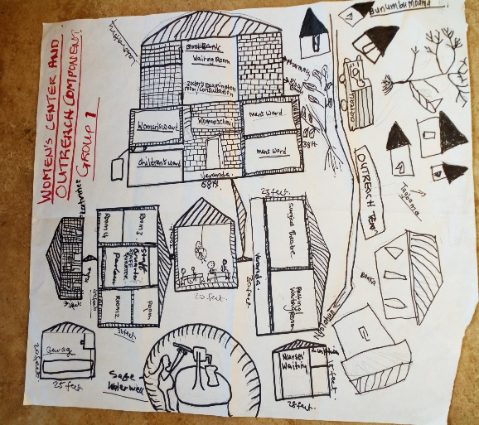 |  | - Laboratory  - Two surgical theatres.  - Beddings for addition of patients.  - Dispensary/Pharmacy.  - Water well.
Food/Income Mobilization Design |  |  | - Women’s Gara tying dying training center.  - Cloth weaving center.  - Tailoring and weaving  - Inland Valley Swamp Rice Farming  - Poultry, pig, goat and ship pens, fish pond, and backyard gardening.
Community/ Outreach Education Design | 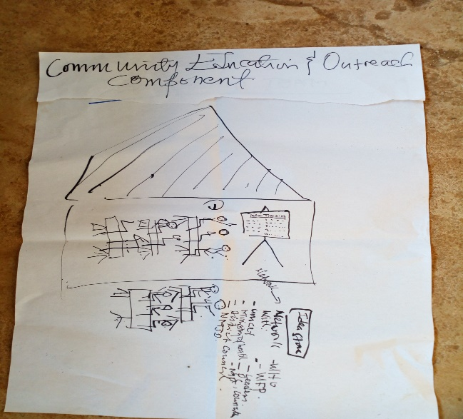 |  | - Monthly mobile clinic services to nearby communities.  - Community outreach education on contraceptive pregnancy an under-five disease prevention and control.  - Ambulance services to and from catchment villages for emergencies.
Strategies For District Medical Office Partnership | 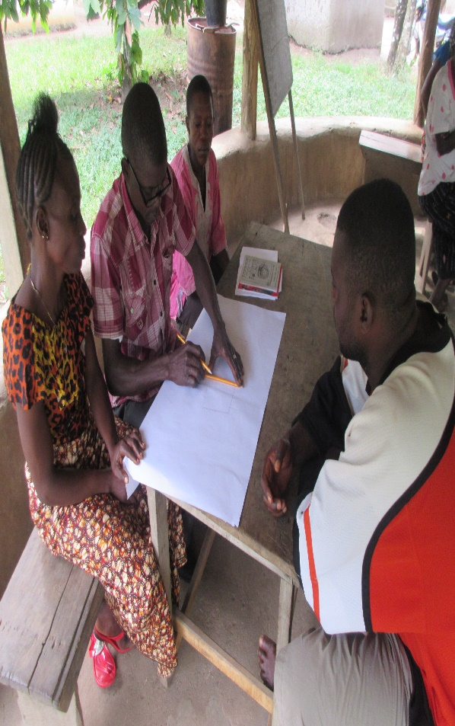 |  | - Conduct monthly coordination meeting with District medical Team.  - Establish partnership with Kailahun District Health Management Team for recognition and medical supplies to the center.  - Network with other agencies including UNICEF, WHO, WFP and others for future food and medical supplies to the center.  - Involve the chiefdom representative of the Ministry of Health and Sanitation in the Facility Management Committee.

Report Form
Community Health Program Logical Framework
Project Component | Main Activity(ies) | Key output (s) | Major outcome (s) | Goal
Women Center Design-Physical Health | 1. Construct a friendly women’s for pre and post natal healthcare.  Service.  2. Organize and outreach and mobile/ popup clinic services to catchment villages. | A functional Women’s Health Center friendly for pre and post natal care service | Vulnerable Pregnant/lactating mothers and under-five can easily access and afford healthcare service. | Reduction in maternal and under-five age deaths in Ngolahun and 4 catchment Villages.
Food/Income Mobilization Design-Economic Health | 1. Community cultivate rice and rear animals.  2. Community provide skills training opportunities for patients. | Vulnerable patients have food and skills available at the women center. | 1. Women’s Center can access affordable food supply service for vulnerable patients.  2. Vulnerable Patients can identify and acquired skills. | Patients have balance diets and knowledgeable in at least one vocational skills from the center
Community and Outreach Education Design-Social Health | Develop a community health education outreach plan. | Catchment villages are aware of the services provided by the women center. | Clinic attendance have increased by Ngolahun and catchment settlements. | Reduction in maternal, under-five age deaths in Ngolahun and 4 catchment Villages.
Strategies For District Medical Office Partnership-Political Health | Identify, select and train Women Center Management Committee to liaise with District Health Management Team. | Village and district health coordination and partnership plan established. | Sierra Leone government approved and coordinate medical supplies to Ngolahun Women Center | Women Center is handed over to the Ministry of Health and partners.

Feedbacks/Reflections
Names | Excitement/surprises (Quotes) | Photos
Baindu Kpau | “Today’s workshop guided my thought on the complete example of our project. This can surely help us as volunteers to start guiding the whole community to plan for its implementation when the time comes”
Yatta Jusu | “This workshop gave me an opportunity to participate in prototyping a project that will save many lives in this village. I am proud that my ideas will be used to design a project to save the life of women that have suffered a lot due to a facility like this.”
Selllu M. Layah | “I feel sad to remember out women that died out of birth complications and walking through a long distance to access health facility. MOH will surely become a light to our path. I am sure our women will be safe in delivery when this project shall have finished.

Way forward/Recommendation/Lessons
- We learnt that Community quest for a women’s center matched with the four interweaved components model of approach
- Invite a trained and qualified nurses or in-charges from the nearest health center to this session to better guide volunteers in designing a health facility for rural areas.

Supervised by Chairman MOH Advisory Committee

